**8th Semester Outcome**

**Submitted Paper:**

“A Nudity Detection Algorithm for Web based Online Networking Platform,” CCICT2022 (Fifth

International Conference on Computational Intelligence and Communication Technologies),

2022

(IEEE Scopus)

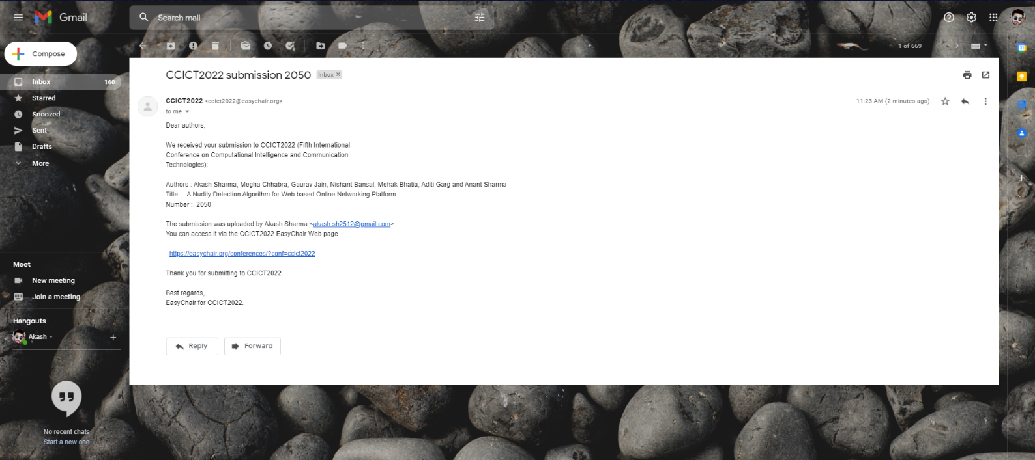

**Hackathon Participation Certification:**

